Carbon Reduction Plan
Supplier name: Meliorate Institute Education & Training Ltd
Publication date: 23.05.23

Commitment to achieving Net Zero
MI Education & Training Ltd is committed to achieving Net Zero emissions by 2050.

Baseline Emissions Footprint
Baseline emissions are a record of the greenhouse gases that have been produced in the past and were produced prior to the introduction of any strategies to reduce emissions. Baseline emissions are the reference point against which emissions reduction can be measured.

Baseline Year: 2023
Additional Details relating to the Baseline Emissions calculations.
MI lease their offices and do not have ownership of the power supplier used. Our employees work from home on average 85% of their time. There is a small amount of commuting which is the result of Covid restrictions.
Baseline year emissions:
EMISSIONS | TOTAL (tCO2e)
Scope 1 | .6
Scope 2 | 3.9
Scope 3  (Included Sources) | 139.4
Total Emissions | 143.88

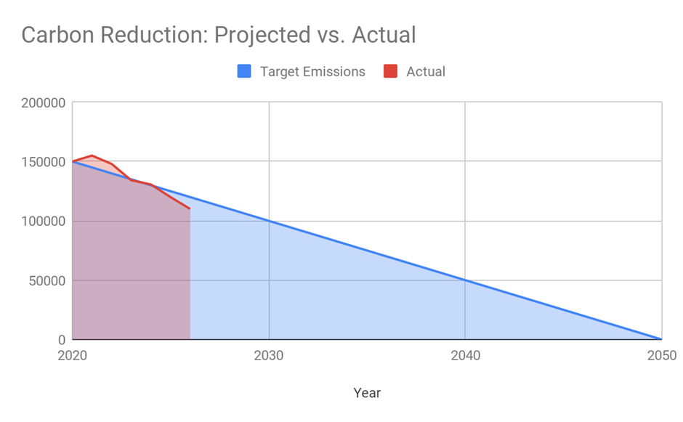
Carbon Reduction Projects
In the future we hope to implement further measures such as:
[Instructions to Suppliers:]

MI is introducing an Electric Car scheme, encouraging all employees to own an electric car, we are in the process of introducing a Salary sacrifice electric vehicle scheme, enabling employees to own or lease an electric car via salary sacrifice.

MI is reducing air travel, train and road travel by encouraging online/virtual meetings for learners and client interactions, this is successful but there are times when a face-to-face meeting is necessary, this will lead to lower vehicle emissions.

We are introducing an LED PIR light policy, where all lights used in office are LED.

MI is working with suppliers who currently have a carbon reduction plan, those who haven’t we are building awareness and encouraging suppliers to create a CRP.

MI is running to plant a tree incentive for every five learners onboarded for apprenticeships.

Declaration and Sign Off
This Carbon Reduction Plan has been completed in accordance with PPN 06/21 and associated guidance and reporting standard for Carbon Reduction Plans.

Emissions have been reported and recorded in accordance with the published reporting standard for Carbon Reduction Plans and the GHG Reporting Protocol corporate standard and uses the appropriate Government emission conversion factors for greenhouse gas company reporting.
Scope 1 and Scope 2 emissions have been reported in accordance with SECR requirements, and the required subset of Scope 3 emissions have been reported in accordance with the published reporting standard for Carbon Reduction Plans and the Corporate Value Chain (Scope 3) Standard.
This Carbon Reduction Plan has been reviewed and signed off by the board of directors (or equivalent management body).

Signed on behalf of the Supplier:

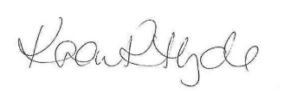
Signed
Karen Hyde
Policy Title | Continual Professional Development Policy and Procedure
Policy version number | MIET-162
Latest version date | 04/09/2026
New review date | September 2027
Owner | SMT
Version History | Version date | Change summary
 | 25/05/2023 | Document creation
 | 02/12/2024 | No changes
 | 13/03/2025 | Updated to reflect branding change
Financial Controller

Version Information

2026 Review and Update
This plan was reviewed on 4 September 2026. The organisation remains committed to achieving Net Zero emissions by 2050. The 2023 baseline remains the documented baseline in this plan. Current-year emissions have not been inserted because they require verified organisational activity data and the applicable UK Government greenhouse-gas conversion factors. Before this plan is used for a procurement that requires a current Carbon Reduction Plan, MI will calculate and approve the latest reporting-year Scope 1, Scope 2 and required Scope 3 emissions and confirm progress against the baseline.

Current reduction actions

• prioritise virtual meetings where effective and reduce unnecessary business travel;

• use energy-efficient lighting and equipment and switch off equipment when not required;

• consider lower-emission travel and vehicle options where practicable;

• engage key suppliers on carbon reduction and environmental performance;

• review energy, travel, waste and procurement data annually and retain evidence supporting reported emissions.

Governance
The Senior Management Team is responsible for annual review. Any public or tender-specific version will be approved by the board or equivalent management body and will state the reporting period and methodology used.

https://ghgprotocol.org/corporate-standard
https://www.gov.uk/government/collections/government-conversion-factors-for-company-reporting
https://ghgprotocol.org/standards/scope-3-standard

